In my research on “Shedding Light on Dark Data: The Critical Role of the Scientific Data Officer,” I investigated the hidden, unutilized data that lurks within enterprises, known as dark data. My journey began with the understanding that massive volumes of data are being gathered, kept, and then ignored, rendering them invisible to the data-driven decision-making processes that modern enterprises aspire for. I focused on understanding the scale of dark data, its implications for business and scientific communities, and the potential roles and responsibilities of a Scientific Data Officer in bringing this hidden data to light. The initial phase involved gathering data, conducting interviews with data scientists and officers, and reviewing existing literature on data management practices. This stage was crucial for setting the groundwork for a deeper investigation into how organizations can better identify, manage, and leverage dark data for strategic advantage.

Throughout the research process, I experienced a mix of excitement and overwhelm. The excitement stemmed from delving into a relatively unexplored area with significant potential for impact. The concept of dark data itself was intriguing, representing a frontier of knowledge waiting to be utilized. On the other hand, the sheer volume and complexity of dark data presented an overwhelming challenge. Feeling daunted by the task of not only understanding but also proposing frameworks to manage this data effectively was a constant during the initial stages of my research. The responsibility of advocating for a new organizational role, the Scientific Data Officer, to spearhead these efforts added a layer of seriousness and urgency to my work.

The evaluation of my work reveals a blend of successes and challenges. Positively, my ability to gather comprehensive insights through literature review and interviews went well, providing a solid foundation for the study. The engagement with data professionals offered valuable perspectives that enriched the research. However, I faced difficulties in accessing detailed case studies of organizations successfully managing dark data, which limited the depth of practical examples I could include. Additionally, the complexity of proposing a new role within the organizational structure, such as the Scientific Data Officer, was more challenging than anticipated, requiring careful consideration of existing roles and corporate dynamics.

In reflecting on the challenges encountered during my research, I believe that several strategies could have improved my approach. First, employing more sophisticated data analysis tools like NVivo for qualitative data could have provided deeper insights into the management of dark data. Additionally, seeking collaborations with IT departments within organizations for case studies could have offered practical examples of dark data management. Engaging with academic and professional networks earlier in the research process might have also provided access to unpublished studies or ongoing research in the field. These steps could have broadened the scope of my research and enriched the practical applications of my findings.

Reflecting on the process and outcomes of my study, I believe that future studies would benefit considerably from early and proactive contact with possible partners, both within academia and in industry. Using advanced data analysis tools and procedures from the start can increase the depth and relevance of study findings. Next time, I would prioritize establishing partnerships with organizations for case studies and practical insights. To avoid the pitfalls encountered, I plan to integrate a more structured approach to identifying and accessing dark data, including a clearer framework for the proposed role of the Scientific Data Officer, ensuring its relevance and feasibility in various organizational contexts. This experience has underscored the importance of adaptability, thorough planning, and the pursuit of collaborative opportunities to enrich research outcomes.

To act on the conclusions from my research, my action plan includes:

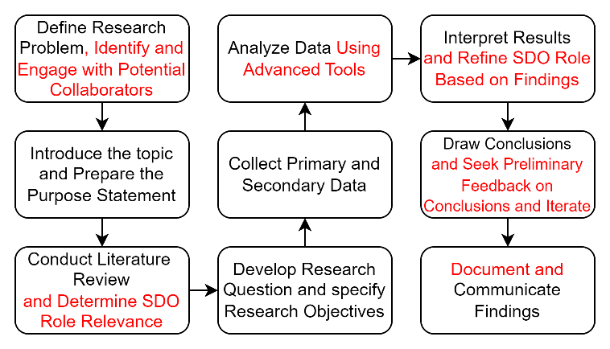

**Figure 1 – Flowchart with an Incorporated Action Plan**

1. **Engage Early with Collaborators:** Begin outreach to potential academic and industry partners at the project’s inception to build a robust network for sharing data and insights.
2. **Utilize Advanced Tools:** Integrate advanced data analysis tools such as Excel and NVivo from the start to enhance data analysis capabilities.
3. **Refine the SDO Role Framework:** Work on refining the role and responsibilities of the Scientific Data Officer to ensure it aligns with organizational needs and structures.
4. **Seek Feedback and Iterate:** Regularly seek feedback on the research framework and findings from both academic peers and industry practitioners to refine the approach continuously.
5. **Document and Share Learnings:** Keep a detailed record of the research process, challenges, solutions, and outcomes to share with the broader research community.

This plan is committed to enhancing the effectiveness of future research on dark data and the SDO role, aiming to contribute valuable insights to the field.

The recommendations below are based on our action plan and the research findings. These proposals seek to solve the identified challenges and build on the successes, therefore increasing the effectiveness as well as the effect of future research efforts in this field:

1. **Institutionalize SDO Role:** Establish the Scientific Data Officer (SDO) role as central to data management to bridge data source gaps and improve decision-making. This responds to Big Data’s growing complexity and ensures alignment with organizational goals.
2. **Advanced Data Classification:** Adopt frameworks to categorize data into critical, dark, or ROT (Redundant, Obsolete, or Trivial) to enhance management and reduce costs. Effective classification is key to optimizing data utilization and compliance.
3. **Invest in Data Management Tech:** Support the SDO with technologies for Big Data analysis and lifecycle management, reducing dark data and boosting efficiency. Tools like semantic analysis and deep learning algorithms offer transformative potential.
4. **Cultivate a Data-Driven Culture:** Promote data appreciation across all levels, emphasizing its strategic importance. A data-driven culture aids in managing dark and ROT data, supporting the SDO’s data management efforts.
5. **Continuous Learning for Data Teams:** Implement ongoing training for the SDO and data management teams on the latest data science and governance trends. Keeping abreast of developments ensures effective Big Data management and governance.
6. **Strategic Partnership Development:** Develop strategic partnerships early with academia and industry, including professional associations and technology firms, to broaden access to diverse dark data insights and management strategies.
7. **Advanced Analytical Frameworks:** Incorporate and master advanced data analysis tools and methodologies beyond Excel and NVivo to uncover complex data patterns and enrich research findings with deeper insights.
8. **Comprehensive Role Definition for the SDO:** Refine the SDO role through extensive research involving interviews and surveys, tailoring responsibilities to fit various organizational contexts for effective dark data management.
9. **Iterative Feedback Loop:** Establish an iterative feedback mechanism with expert panels for continuous refinement of the research framework, ensuring relevance and alignment with industry and academic advancements.
10. **Knowledge Dissemination:** Implement a detailed plan for sharing research outcomes through open-access publications, online resources, and presentations at conferences, contributing to the dark data and SDO knowledge base.
11. **Pilot Implementation Projects:** Conduct pilot projects in partnership with organizations to apply research findings on the SDO role and dark data strategies, providing practical insights and valuable case studies.